- Log on to https://nfhslearn.com/
- Click the “Register” button in the top right corner of the page
- If you have not already done so, register for an account. Use a valid email as it must be verified for it to work.
- Once you have registered and signed in, go to your “Dashboard” page and click on the “My Courses” button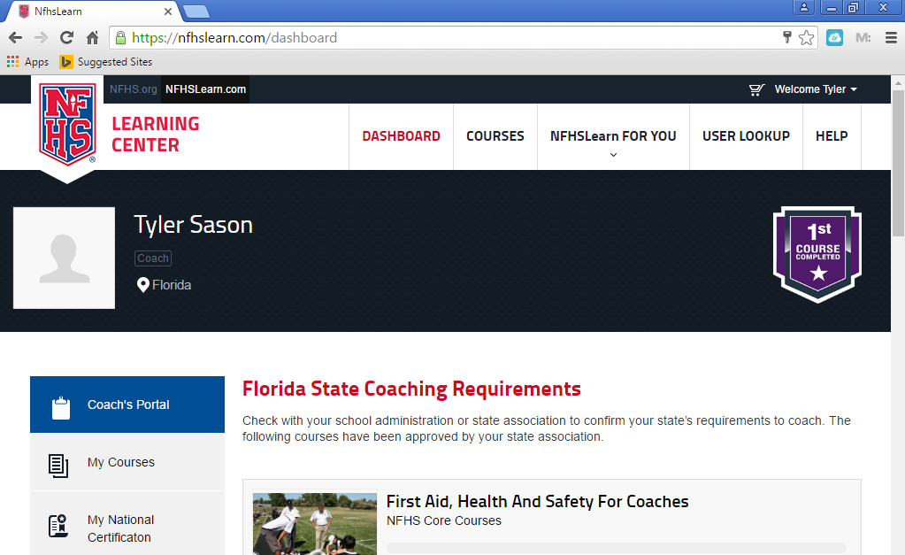
- Register for the following courses (registration is free) and complete the checkout process:
  - Concussion in Sports
  - Sudden Cardiac Arrest
  - Heat Illness Prevention
  - Sports Nutrition
  - Social Media for Students
  - Sportsmanship
  - Bullying, Hazing, and Inappropriate Behaviors
  - Appearance and Performance Enhancing Drugs
- Courses that you are registered for will appear under the “My Courses” button on your dashboard.
- Complete each course and print the certificate at the end of each course. All course certificates are due to Coach Sason by the end of practice on July 31.

